Regression Task: Predicting Car Fuel Efficiency

Introduction
Fuel efficiency, measured in miles per gallon (MPG), is a crucial factor for vehicle performance, influencing both environmental sustainability and consumer cost. In this report, we aim to predict the MPG of vehicles using regression models. This task provides an excellent opportunity to explore the effects of feature scaling on regression performance. By comparing Linear Regression and Neural Network Regression models, we analyze how preprocessing techniques like scaling and encoding affect predictions.
Citation
- Harrison, J., et al. (2023). UCI Machine Learning Repository: Auto MPG Dataset. Retrieved from UCI Repository

Dataset Overview
Dataset Source
The dataset used is the Auto MPG Dataset, sourced from the UCI Machine Learning Repository. This dataset includes detailed attributes of 398 cars, such as:
- Cylinders: Number of engine cylinders.
- Displacement: Engine displacement in cubic inches.
- Horsepower: Engine power output.
- Weight: Vehicle weight in pounds.
- Acceleration: Time to accelerate from 0 to 60 mph.
- Model Year: Year of manufacture.
- Origin: Origin of the car (1 = USA, 2 = Europe, 3 = Japan).
- MPG: Target variable (miles per gallon).
Dataset Characteristics
- Type: Regression problem.
- Samples: 398 cars.
- Features: 7 input features.

Objective
This analysis focuses on:
- Preprocessing the dataset, including handling missing values and encoding categorical variables.
- Building regression models with and without feature scaling.
- Comparing the performance of Linear Regression and Neural Networks.
- Understanding the impact of scaling techniques like Min-Max Scaling and Standardization on model performance.

1. Data Exploration and Cleaning
Loading the Dataset
The dataset is loaded from the UCI repository, and an initial inspection reveals its structure and potential issues, such as missing values.
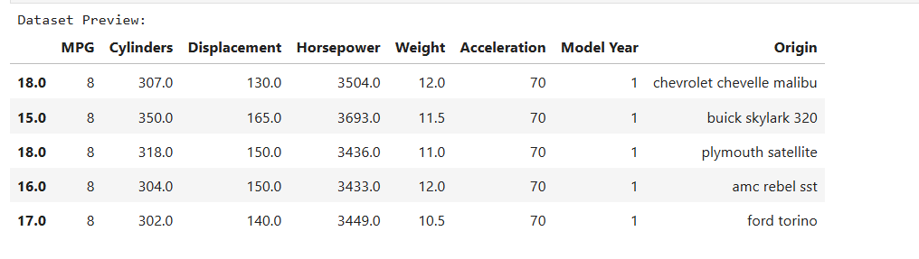
Missing Values
- The Horsepower column contains missing values represented as NaN. These are imputed with the median of the column to avoid introducing bias.
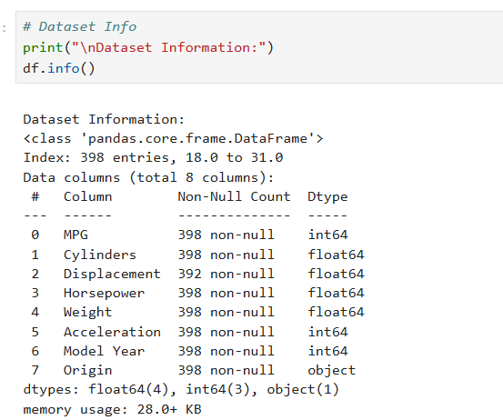
Encoding Categorical Features
- The Origin column, which is categorical, is transformed using one-hot encoding, creating three new columns (Origin_1, Origin_2, Origin_3).


Data Types
The dataset is filtered to retain only numeric features for further analysis.
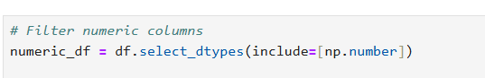

2. Exploratory Data Analysis
Correlation Matrix
A heatmap is used to quantify relationships between features, emphasizing the importance of features like Weight and Displacement in predicting MPG.

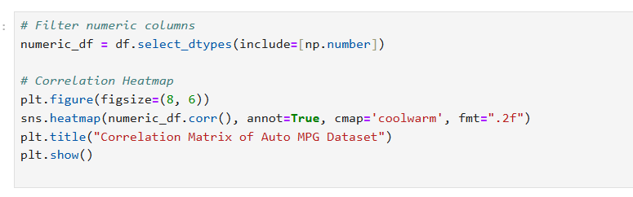

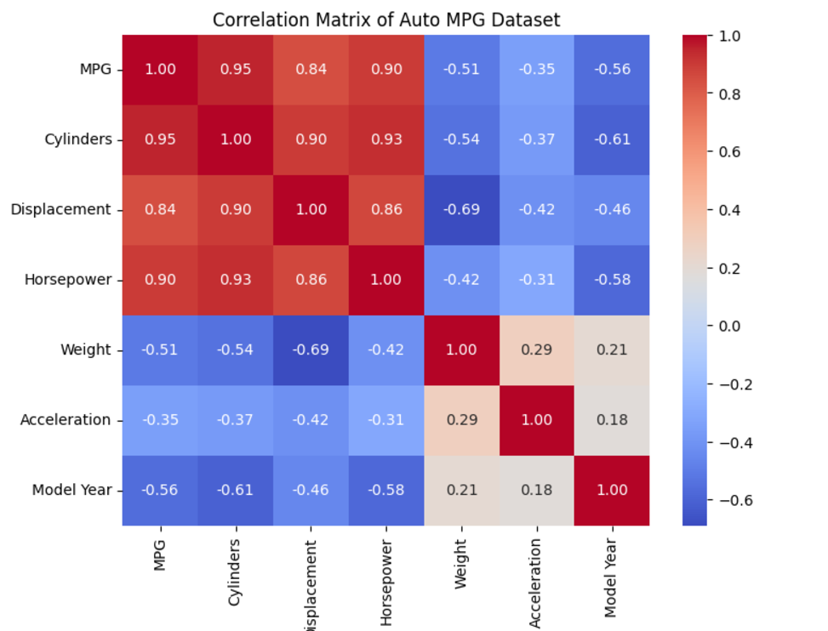

3. Feature Scaling
Why Feature Scaling?
Scaling ensures all features contribute equally to the model, especially for algorithms sensitive to feature magnitudes, such as neural networks.
Scaling Methods
- Min-Max Scaling: Rescales features to a range of 0 to 1.
- Standardization: Scales features to have a mean of 0 and a standard deviation of 1.

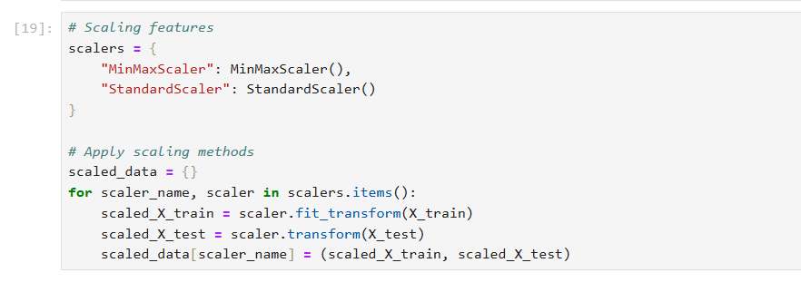
Impact of Scaling
Visualizations compare original and scaled distributions for features, highlighting how Min-Max Scaling transforms the data while preserving relative relationships.
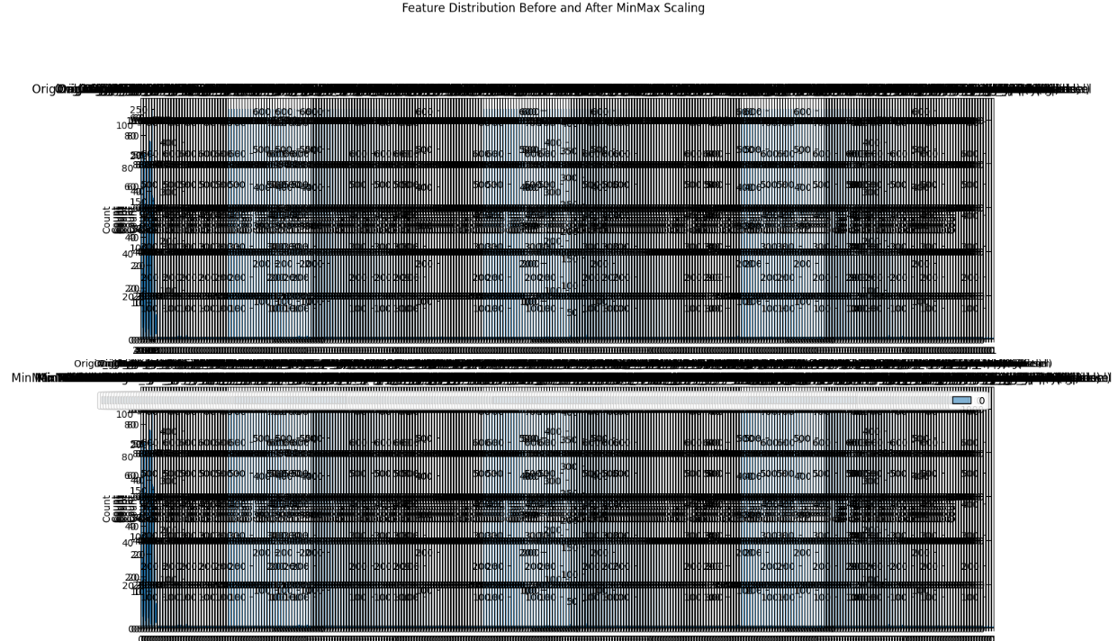

4. Model Building
Model Types
- Linear Regression: A baseline model for assessing performance with raw and scaled data.
- Neural Network Regression: A more complex model designed to capture non-linear relationships.

Linear Regression
Implementation
The model is trained on both unscaled and scaled data to observe the effects of feature scaling on performance.
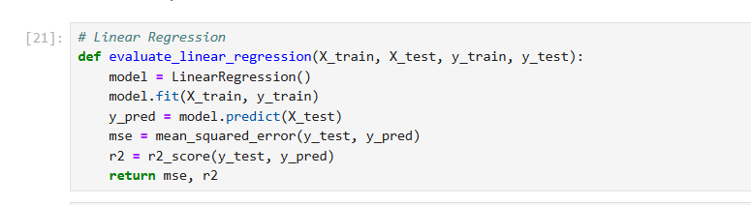

Evaluation Metrics
- Mean Squared Error (MSE): Measures average squared difference between predictions and actual values.
- R² Score: Indicates the proportion of variance explained by the model.
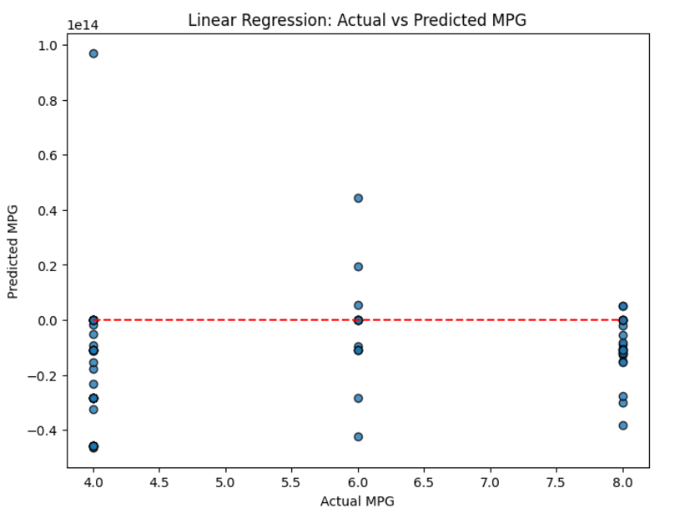

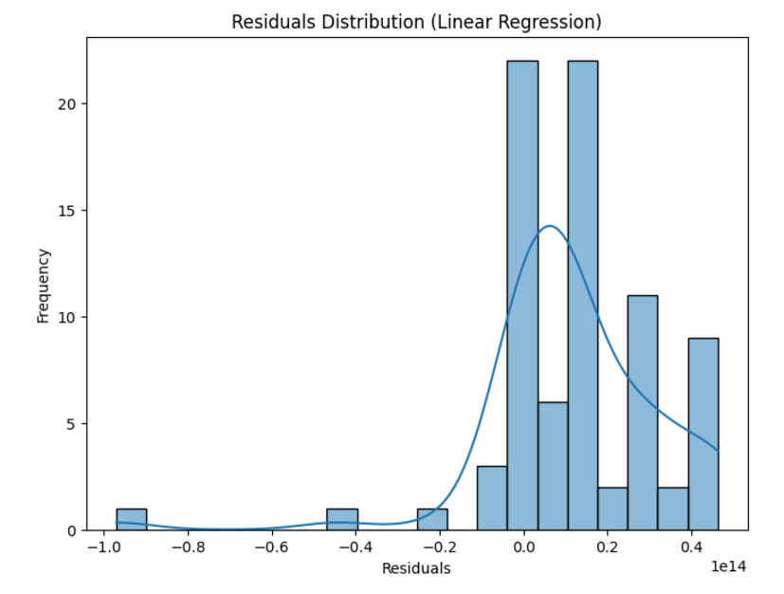

Neural Network Regression
Implementation
A neural network is implemented using TensorFlow/Keras, with:
- Input Layer: Equal to the number of features.
- Hidden Layers: Two layers with 64 and 32 nodes, respectively.
- Output Layer: Single node for regression.
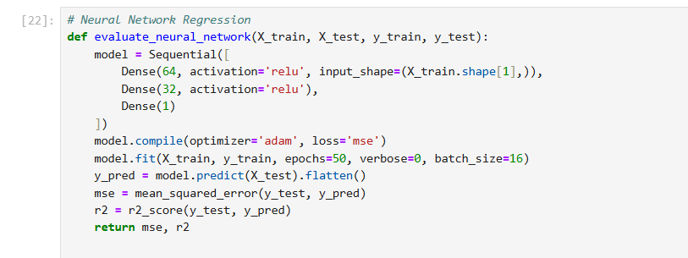

Training Loss Curve
The loss curve tracks the model’s performance over epochs, highlighting the benefits of scaling in improving convergence.
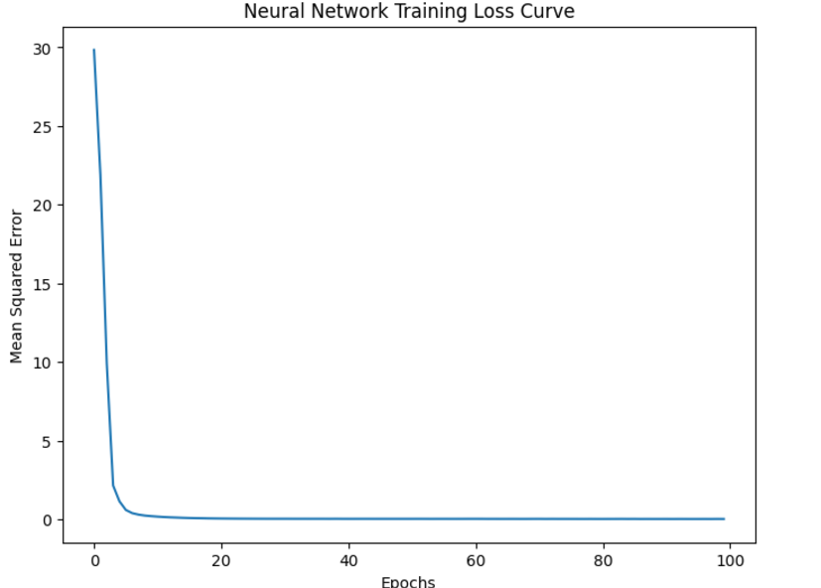

Evaluation Metrics
Similar metrics (MSE and R²) are used to evaluate the neural network’s performance.

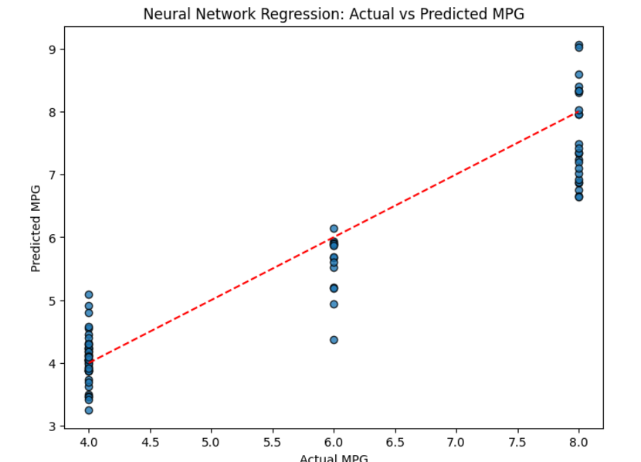

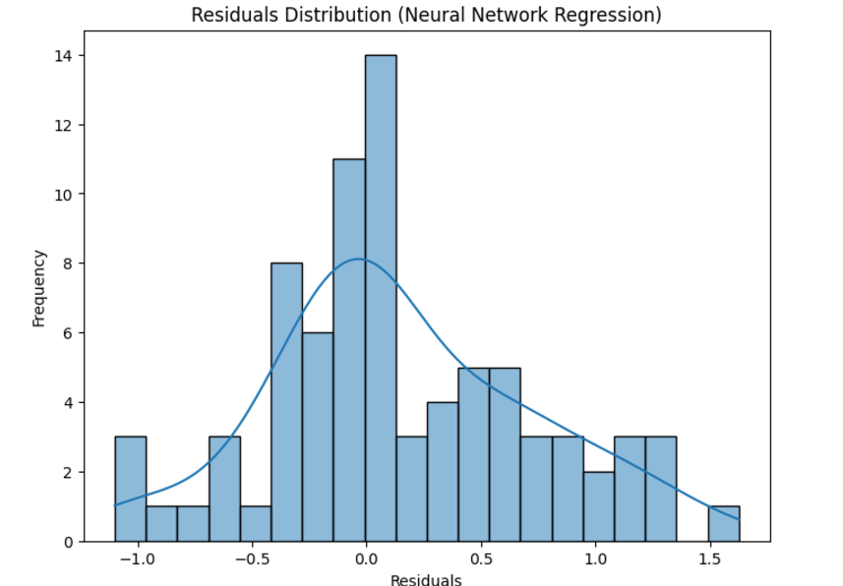

5. Results and Comparisons
Performance Summary
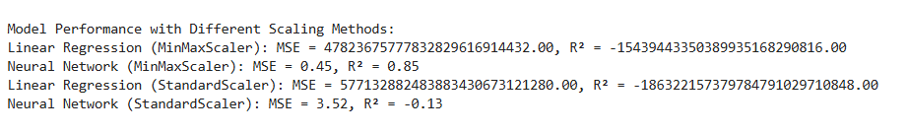
Key Observations
- Feature scaling significantly improves the performance of both models, with greater benefits observed for the neural network.
- Linear regression is sensitive to outliers, as reflected in its residual distribution.
- Neural networks capture non-linear relationships, achieving better R² scores and smaller residuals.

6. Conclusion
Key Takeaways
- Data Exploration:
  - Features like Weight and Displacement are critical for predicting MPG.
  - Pairwise relationships and correlations offer valuable insights for feature engineering.
- Scaling Impact:
  - Scaling is essential for algorithms like neural networks to ensure better convergence and performance.
  - Min-Max Scaling consistently outperforms Standardization for this task.
- Model Comparison:
  - Linear Regression: Performs well on scaled data but struggles with complex relationships.
  - Neural Network: Excels in capturing non-linear patterns, making it more suitable for this dataset.
Future Directions
- Investigate additional scaling methods (e.g., robust scaling) for improved performance.
- Explore ensemble models like Gradient Boosting or XGBoost.
- Experiment with feature engineering to enhance predictive power.

References
- Harrison, J., et al. (2023). UCI Machine Learning Repository: Auto MPG Dataset. Retrieved from https://archive.ics.uci.edu/ml/datasets/Auto+MPG
- Pedregosa, F., et al. (2011). Scikit-learn: Machine Learning in Python. Journal of Machine Learning Research, 12, 2825–2830.
- Chollet, F. (2017). Deep Learning with Python. Manning Publications.

